Banking Logistic Regression (Loan Approval + Complex Risk) – 1-Page Summary

Problem Statement
A regional bank needs transparent, auditable models that turn underwriting features into approve/decline decisions. Two classic settings are addressed: (1) personal-loan approval based on a Credit-Score proxy and a DTI-related score (roughly linear separation), and (2) a more complex credit product whose two risk indicators form a non-linear “acceptable risk” region. The goal is to implement logistic regression from first principles, add polynomial feature mapping + L2 regularization for the non-linear case, and expose the decision threshold as a controllable risk-appetite lever.

Solution Strategy
• Implement the sigmoid and binary cross-entropy cost/gradients (loop + vectorized).
• Train a linear model on the loan-approval data and plot the P=0.5 decision boundary.
• Expand the complex-risk scores to degree-6 polynomials; add L2 regularization; recover a smooth closed boundary.
• Treat the classification threshold as a policy parameter (volume vs selectivity).
• Provide sklearn baselines, λ-sensitivity simulation, and audience-adapted narratives for Credit Risk, Underwriting and the Risk Committee.

Solution
The linear loan-approval model reaches ~91 % training accuracy with a clear straight decision boundary. After polynomial expansion and modest L2 regularization (λ ≈ 1) the complex-risk classifier reaches ~82 % accuracy and produces a smooth closed contour. Stronger regularization lowers accuracy but yields a more conservative, generalizable policy boundary — the classic volume-versus-risk trade-off that Risk Committees care about.
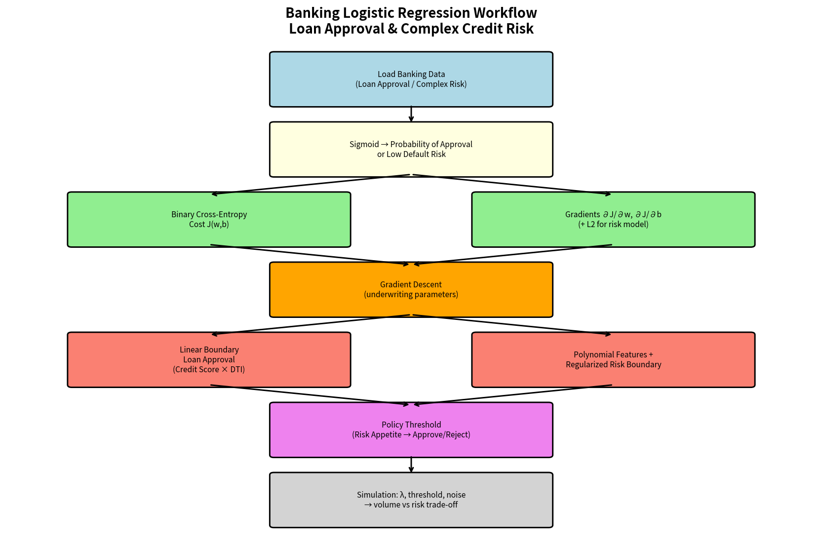
Figure 1 – End-to-end banking logistic-regression workflow
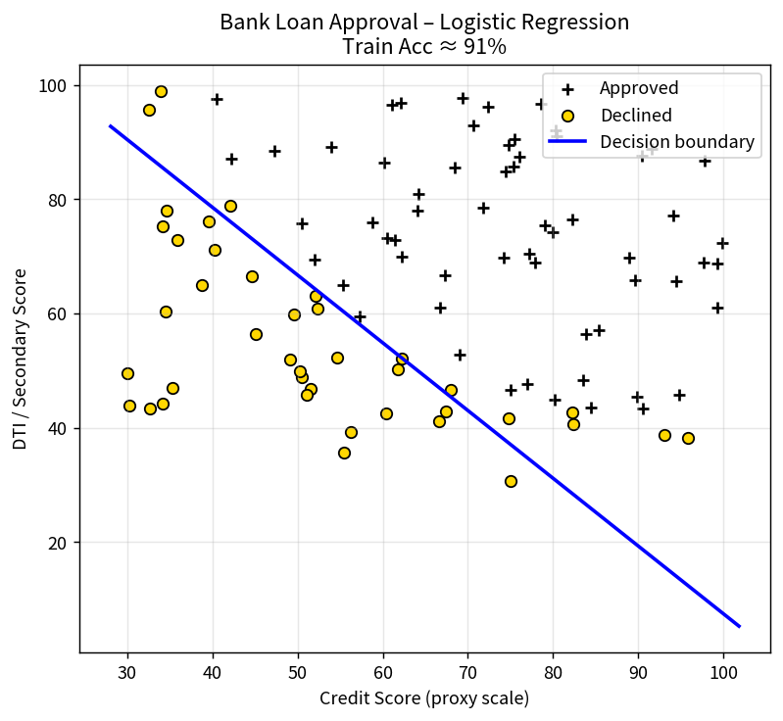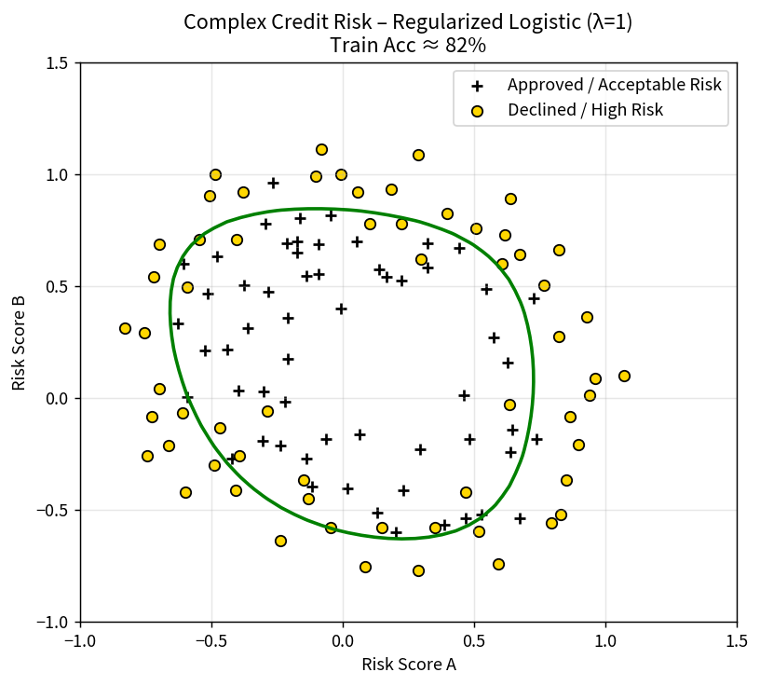
Figure 2 – Linear loan-approval boundary (left) vs regularized complex-risk boundary (right)

Key Takeaways
• Logistic regression maps an underwriting score into a calibrated probability; the threshold is a separate policy choice that encodes risk appetite.
• Feature mapping + L2 regularization allows a linear classifier to capture non-linear risk regions while controlling over-fit — essential for complex products.
• Always visualise the decision boundary; regulators and Risk Committees expect to see the policy geometry, not only an accuracy number.
• Different audiences need different depth: Credit Risk wants the mathematics, Underwriting wants the boundary plots, Executives want the volume-versus-risk sentence.
• The reusable template and simulation cells make it straightforward to re-apply the same pipeline to any new two-feature credit-risk data set.

